University Of Engineering and Technology, Lahore
Computer Engineering Department

Course Name: Object Oriented Programming | Course Code: CMPE-221L
Assignment Type:Lab | Dated: 1-07-2026
Semester: 2nd | Session: CYS 2025 SPRING
Lab/Project/Assignment #: 1 | CLOs to be covered: CLO1
Lab Title: Getting Started | Teacher Name: Hafiz Muhammad Mubashar
Lab Evaluation:

CLO1 | Apply appropriate programming techniques to create executable programs to solve well defined problems
CLO1 | Level1 | Level2 | Level3 | Level4 | Level5 | Level6
(5)
Total |  |  |  |  |  | /5
Rubrics for Current Lab Evaluation
Scale | Marks | Level | Rubric
Excellent | 5 | L1 | Submitted all lab tasks, BONUS task, have good understanding.
Very Good | 4 | L2 | Submitted the lab tasks but have good understanding
Good | 3 | L3 | Submitted the lab tasks but have weak understanding.
Basic | 2 | L4 | Submitted the lab tasks but have no understanding.
Barely Acceptable | 1 | L5 | Submitted only one lab task.
Not Acceptable | 0 | L6 | Did not attempt
LAB No 1
Lab Goals/Objectives:
Getting Started with Java
Acquiring practice with familiar programming constructs in JAVA

Equipment Required:
Inteli J IDEA Edition Community, Net Beans with JDK 13 Version,
Visual Studio.

Theory:
Write First Java Program

Lab Tasks:
1. Change the Factorial code discussed in class so that it shows proper messaging in case of negative numbers.
2. Change the Series_Generator such that it can generate both increasing series or decreasing series depending on the
starting and ending values.
3. Write a Program that takes year as an input from user and determine if it’s a leap year or not.
Sample input
>>>
Enter Any Year: 1940
It is a leap year
4. You are interested in calculating your electricity bill of your home. You know the unit consumption of your home.
Billing criteria for electric company is that it charges 5 Rs/ unit for first 100 units, next 100 units are charged at 7
Rs/unit and above that charge is 15 Rs/unit. As input, you get total_Units consumed and generate bill.
Sample input
>>>
Enter Units Consumed: 150
Bill: 850
5. Write a program that takes an integer n from command-line arguments and uses a while loop to compute the
number of times you need to divide n by 2 until it is strictly less than 1. Print the error message “Illegal input” if n
is negative.
Sample input
>>> n: 8 Div: 4
>>> n: 4
Div: 3
6. Write a code that takes a number value from user and displays the inverse of it. Number can be of any length.
Sample input
>>>
Number: 151
Inverse: 151
>>>
Number: 1567
Inverse: 7651

Task 1:
import java.util.Scanner;
public class fact {
public static void main(String[] args){
Scanner sc = new Scanner(System.in);
System.out.print("enter the number whose factorial you want to calculate:");
int num = sc.nextInt();
System.out.println("you entered" + num);
int fact = 1;
for (int i=num;i>0;i--){
fact=fact*i;

}
System.out.println("the factorial of the number you entered is" + fact);
}

}

Result:

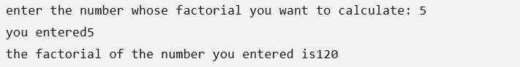

Task 2:
import java.util.Scanner;
public class series {
public static void main(String[] args){
Scanner sc= new Scanner(System.in);
System.out.print("enter the starting number");
int start= sc.nextInt();
System.out.print("enter the ending value");
int end=sc.nextInt();
if (start<end){
for(int i=start; i<=end; i++ ){
System.out.println(i);
}
}else{
for(int i=start;i>=end;i--){
System.out.println(i);
}

}

}
}

Result:

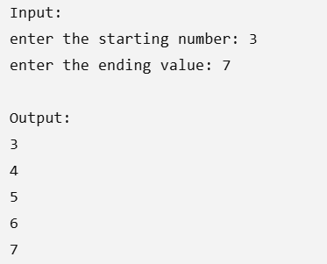

TASK 3:
import java.util.Scanner;
public class leapyear {
public static void main(String[] args){
Scanner sc= new Scanner(System.in);
System.out.println("enter the year");
int year=sc.nextInt();
if(year%4==0){
System.out.println("Its a leap year");
}else{
System.out.println("Its not a leap year");
}
}

}

RESULT:
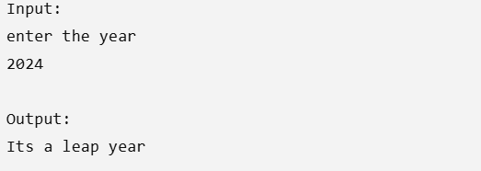

TASK 4:

import java.util.Scanner;
public class electricity {
public static void main(String[] args){
Scanner sc = new Scanner(System.in);
System.out.println("enter the units you consumed");
int units = sc.nextInt();
int bill=0;
if(units<=100){
bill = units*5;

} else if (units<=200) {

bill = (units * 5) + (units-100) * 7;

}else{
bill=( units * 5)+((units-100) * 7) + ((units-200) * 15);
}
System.out.println("the total bill is" + bill);

}
}

RESULT:
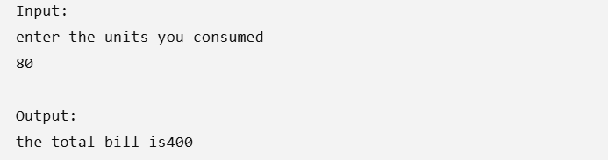

TASK 5:
public class negative {
public static void main(String[] args){
int num= Integer.parseInt(args[0]);
if (num<0){
System.out.print("illegal input");
}else{
int count=0;
while(num>=1){
num=num/2;
count +=1;
}
System.out.println("div:" + count);
}
}

}

RESULT:

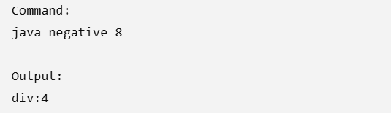

TASK 6:
import java.util.Scanner;
public class inverse {
public static void main(String[] args){
Scanner sc= new Scanner(System.in);
System.out.print("enter a number");
int num = sc.nextInt();
int inverse=0;
while(num>0){
int digit= num%10;
inverse= inverse * 10 + digit;
num = num / 10;
}
System.out.println("the inverse is" + inverse);
}
}

RESULT:

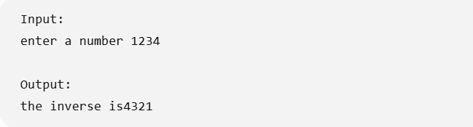

Conclusions:
These Java programs demonstrate the use of fundamental programming concepts such as user input (Scanner and command-line arguments), variables, arithmetic operations, conditional statements (if-else), loops (for and while), and basic algorithms. They solve simple real-world problems like checking leap years, calculating electricity bills, finding factorials, reversing a number, printing a range of numbers, and repeatedly dividing a number by 2. Overall, these programs help build a strong understanding of Java basics, logical thinking, and problem-solving skills, which form the foundation for developing more advanced Java applications.

